**SEMESTER PROJECT REPORT**

Analyze the dynamic Response of the Beam using MATLAB

Ishan Sharma

Graduate Student, Department of Mechanical Engineering

Clemson University

Index

* Introduction……………………………………………………………………………………3
* Summary………………………………………………………………………………………5
* Solution Procedure…………………………………………………………………………….6
* Implementation using MATLAB……………………………………………………………..15
* Observations & Results……………………………………………………………………….16
* Conclusion…………………………………………………………………………………….18

Introduction

In the given problem, we will analyze the dynamic response of a given cantilever beam for the specified load application. In the current problem, we are about to analyze how the cantilever beam responds to sudden load application. In the given study, we’ll be observing the aspects of dynamics in terms of displacement for a given instant of time over different time-steps.

Figure 1: Dimensions of Cantilever Beam

**Problem Description**

Beam type: Cantilever Beam (Fixed at One End and Free at Other End)

Cantilever Beam Dimensions:

Geometry:

* Length of the Beam: 20cm
* Breadth of the Beam: 0.5 cm
* Height of the Beam: 1cm

Mass Density: 2330 kg/m3

Resultant volume of the beam: (L * B * H) = 0.00001 m3

Resultant Mass of the Beam: 2330 kg/m3

Moment of Inertia of the Beam: 1/12 * B * D3 = 4.16 X 10 -10

Young’s Modulus of the Beam = 90GPa = 90 X 10 9 Pa = 9 X 10 10 Pa

Coefficients involved:

* Mass Coefficients: 2.0
* 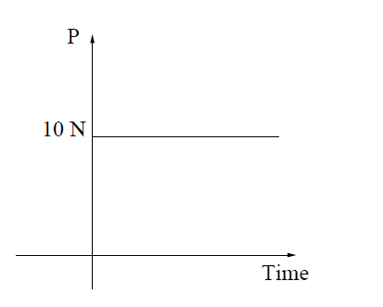Stiffness Coefficients: 10 -4

Figure 2: Applied Load Profile

Load Profile:

* Applied Load: 10 N

Summary

The procedure to lead the linear structural dynamics analysis of the cantilever beam is carried out. In the given application, the cantilever beam is subjected to a load application of 10N at the free end. Correspondingly, the mass coefficients and stiffness coefficients have been mentioned. A Schematic analysis scheme is developed to work through the elements of dynamic analysis using FEA into a step-by-step approach, starting from formulating the problem to concluding with the problem's defined solution objective.

Solution Procedure

Step – I

**Physical Understanding of the Problem**

In the given application, wherein the Cantilever Beam is a rest initially under the given application of load(P) at the tip of the Beam. The geometric constraints involved have been above mentioned in the problem definition section. We’ll be working through the aspects of dynamic response of the beam analysis using FEA.

Step – II

**Formulating the Mathematical Model for the above problem**

In further analyzing a given problem, formulating a mathematical model is very integral and crucial. The dynamic analysis of a given system can be accomplished by multiple techniques, but we will be specifically hovering through the *Natural Frequencies and modes* and some elements of the *transient analysis*.

We will start to deduce the governing equations involved by studying single degree of freedom models. Degree of Freedom refers to a single direction that a node is permitted to move or rotate. A system with single degree of freedom only has one permissible direction to move or rotate in each system. These single degree of freedom models are often coupled with two degree of freedom models to generate the governing equations for Automotive Structures and for their Side-Frame Geometry dynamics.

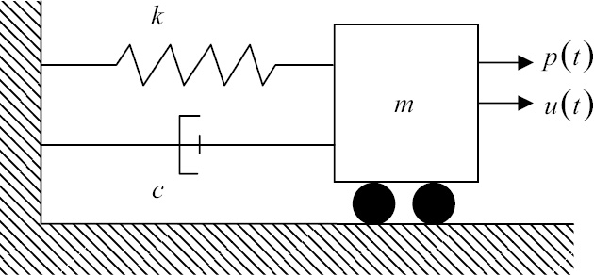

Figure: Single Degree of Freedom (Spring – Mass – Dashpot) Model

$$u\left(t\right):Displacement$$

$$f\left(t\right):Excitation Force (External Force Applied)$$

As per the Newton’s Law of Motion:

$$mass*Acceleration=Force$$

Or

$$m*\frac{d^{2}u}{dt^{2}}=f\left(t\right)-k*u-\frac{du}{dt}$$

*Now, as we know*

$$Acceleration :\frac{d^{2}u}{dt^{2}}$$

$$Velocity: \frac{du}{dt}$$

Now, we could have different cases of vibrations, Forced Vibrations and Free Vibration. In a Free Vibration model representation studied in Mechanical Vibrations has been used to work through the formulation of the mathematical model.

Assumptions:

* No inherent damping present across the system i.e. c=0

So, it can be written as -

$m*\frac{d^{2}u}{dt^{2}}= -k*u$*Eq 1*

Wherein the displacement, u can also be represented as for the above system

$u\left(t\right)=A*\sin\left(ω*t\right)$*Eq 2*

*Where,*

$ω:Angular Frequency$

* *A: Amplitude of Oscillations*

*Substituting the value of u from Equation 2 into Equation 1, We get –*

$-m*A*ω^{2}\sin\left(ω*t\right)+k*A*\sin\left(ω*t\right)$*= 0*

$$Taking \left(-ω^{2}*m+k\right) common from the above equation, We get-$$

$$\left(-ω^{2}*m+k\right)U=0$$

$$ω=\sqrt{\frac{k}{m}}$$

Therefore, the above equation helps us to deduce the fundamental frequencies for a given system whose system stiffness and mass is known.

Frequency, thus, obtained from the above formulation will be Undamped Natural Frequency

*(Cyclic Frequency) $f= \frac{ω}{2π}$*

Now, as for the free vibrational model, c is zero. If damping coefficient c is not zero and less than critical damping coefficient Cc

*0 $0 <C<C_{c}$*

*Where, $damping ratio: \frac{Damping Coefficcent}{Critical Damping Coefficcent}$*

$$Critical Damping\left(C_{C}\right):2*\sqrt{k*m}=2*ω*m$$

In most of the Engineering structures and its subcomponents is Damping Ratio is more than 0 and less than 0.15, which holds correct for our cantilever beam application for the given problem.

In continuum structures, equations are initially defined for infinitesimal small volume and the results are integrated over along the given domain

Now, Talking through the aspects of linear elasticity

Consider, the situation, where stress in three dimensions need to calculate. In a 3D Region Ω, with a linear elastic solid.

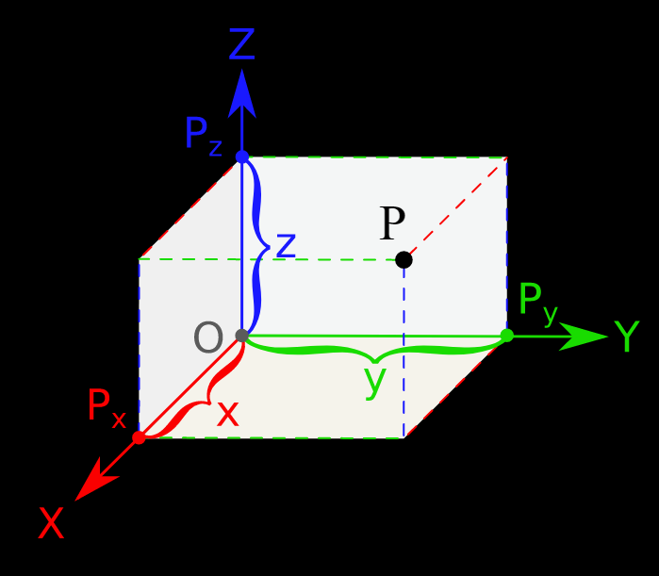

Ω

P (u, v, w)

The origin O (x, y, z), the displacement at point P with respect to origin, as per the right handed convention system has components (u,v,w) measured with respect to the global reference axis as defined in the above picture.

The entire domain boundary Ω is denoted by ℾ. ℾ is further categorized into two parts:

* ℾu: Domain where displacements are specified
* ℾt: Domain where surface traction is specified

Now, take a normal vector **n** normal to the boundary normal to Ω and has components (nx , ny, nz )with respect to the global system.

$$ℾ= ℾ_{u} U ℾ_{t}$$

Now, with the above system definition, we could define our set of differential equations of Equilibrium and Motion respectively for our given application using the principles of conservation of energy along the infinitesimal small volume of element. Where the force along its different faces is calculated.

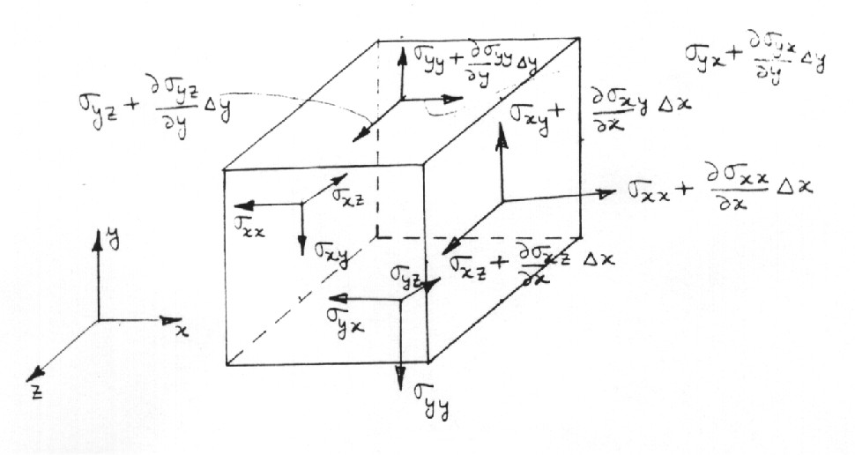

Figure: Force Balance along the x, y and z direction (Shear is neglected at this point)

Figure: Force Balance on the infinitesimal element of domain Ω

Convention Utilized for Force Balance:

Force coming into the system are taken as positive and force leaving the system are negative.

Hence, we obtain the resultant differential equations of Equilibrium

**Differential Equations of Equilibrium**

In one direction, as follows in x direction -

$$\frac{∂σ_{xx}}{∂x}+ \frac{∂σ_{yx}}{∂y}+ \frac{∂σ_{zx}}{∂z}+b_{x}=0$$

Similarly, for other directions (y and z respectively) -

$$\frac{∂σ_{xy}}{∂x}+ \frac{∂σ_{yy}}{∂y}+ \frac{∂σ_{zy}}{∂z}+b_{y}=0$$

$$\frac{∂σ_{xz}}{∂x}+ \frac{∂σ_{yz}}{∂y}+ \frac{∂σ_{zz}}{∂z}+b_{z}=0$$

Where,

**b =** (bx, by, bz) are the respective body forces applied per unit volume.

Together, the above three equations form the *differential equations of Equilibrium.*

**Differential Equations of Motion -**

Furthermore, discussing over the aspects of Differential Equations of Motion, for conditions, wherein the system is not in static equilibrium. The net force applied across the system results in acceleration in the direction of net resultant force. The differential equations of motion are –

$$\frac{∂σ_{xx}}{∂x}+ \frac{∂σ_{yx}}{∂y}+ \frac{∂σ_{zx}}{∂z}+b_{x}=ρ\frac{∂^{2}u}{∂t^{2}}$$

$$\frac{∂σ_{xy}}{∂x}+ \frac{∂σ_{yy}}{∂y}+ \frac{∂σ_{zy}}{∂z}+b_{y}=ρ\frac{∂^{2}v}{∂t^{2}}$$

$$\frac{∂σ_{xz}}{∂x}+ \frac{∂σ_{yz}}{∂y}+ \frac{∂σ_{zz}}{∂z}+b_{z}=ρ\frac{∂^{2}w}{∂t^{2}}$$

In this condition, equation of equilibrium is equated against the net unit acceleration in that given direction. Where, (u, v, w) are the specified displacement coordinates as specified along the x, y and z direction respectively in the earlier sections of the discussion.

In short, the above differential equations of motion can be represented as –

$$△.σ+b= ρ \frac{∂^{2}u}{∂t^{2}}$$

Step – III:

**Derivation of Weak Form**

Method of Virtual work is utilized to derive the weak form for the above problem. As we know that the internal virtual work done is equivalent to external work done as per Method of Virtual Work.

$$W_{Internal Virtual Work}= W_{External Virtual Work}$$

W Internal Virtual Work = Work done by internal stresses in each system

$$W_{I}=h\int_{Ω}{δε.σ dΩ}=h\int_{Ω}{δε.Cε dΩ}$$

For Dynamic System:

W Internal Virtual Work = W Inertial force + W Damping Force

The external virtual work is divided into categories based on the type of forces acting on the body.

$$W_{External work done by Surface Traction}= h\int_{Γ_{t}}{δu.t dΓ}$$

The external virtual work done by the point force is given by

$$W_{External Virtual Work}= δu(a).p$$

The external virtual work done by the body force is given by

$$W_{External Work done by Body Forces}= h\int_{Ω}{δu.b dΩ}$$

Therefore, the final weak form is given as,

W Internal Virtual Work = W External Virtual Work

**Final Resultant Weak Form**

$$\int_{Ω}{δε.Cε dΩ}+\int_{Ω}{δu.ρu̇ dΩ}+\int_{Ω}{δu.Cü dΩ}= \int_{Γ_{t}}{δu.t dΓ}+δu\left(a\right).p/h+\int_{Ω}{δu.b dΩ}$$

Step – IV

**Discretization:**

In the above problem, the 2D cantilever beam is discretized into two different meshed models, namely -

**(i) Coarse Mesh Model (Nodes < 200)**

Where the coarse mesh is divided into 80 elements (40 X 2). The '4 nodes linear quadrilateral' element is used to mesh the coarse mesh model. The degree of accuracy is somewhat less in coarse mesh models, but it is not computationally taxing.

**(ii) Fine Mesh Model (Nodes > 1000)**

Where the fine mesh model is divided into 1280 elements (160 X 8) with 1449 nodes. Even for the fine mesh model, '4 nodes linear quadrilateral' are used. The degree of accuracy is high, but the mesh model is computationally taxing and intensive, leading to higher computational time.

|  |  |  |
| --- | --- | --- |
|  | **Coarse Mesh Model** | **Fine Mesh Model** |
| **Nodes** | 123 | 1449 |
| **Elements** | 80 | 1280 |
| **Computation Time** | Low | High |

A MATLAB code has been designed to generate the mesh for the given requirements. The code utilizes the number of nodes per unit length along the x and y direction as the input to create the mesh for the desired requirements.

Step – V – VII:

**Approximations, Element and Global Matrices and Vectors**

Once the weak form is generated, the generated weak form can be divided into element level using shape functions. In our case, shape functions have been used to approximate the unknowns for the given problem.

As we are dealing with elasticity problem, problem need to be dealt as a vector field. Rest all the formulations remains the same for static structural analysis.

$$\int_{Ω}^{ȩ}{δε.Cε dΩ}+\int_{Ω}^{ȩ}{δu.ρu̇ dΩ}+ \int_{Ω}^{ȩ}{δu.ρ\dot{u}dΩ= \int_{ℾ_{t}}^{ȩ}{δu.t dΓ+ \int_{Ω}^{ȩ}{δu.b dΩ+ \frac{δu\left(a\right).p}{h}}}}$$

The above weak form can be used for element matrix and integrated over the given element domain. In the dynamic analysis, the weak form shown is somewhat similar to the static analysis cases. The only difference is the addition of the inertial and damping effect over the entire system. The equation for the FEA approximation of virtual displacement (δu), velocity (u̇), and acceleration(ü) is represented as -

|  |  |  |
| --- | --- | --- |
|  |  | (1) |

|  |  |  |
| --- | --- | --- |
|  |  |  |

|  |  |  |
| --- | --- | --- |
|  |  |  |

Substituting the above values in the additional terms of weak form we get,

|  |  |  |
| --- | --- | --- |
|  |  |  |

|  |  |  |
| --- | --- | --- |
|  |  |  |

Where mⓔ and cⓔ are called the element mass matrix and element damping matrix as mentioned in the above equations respectively.

Now, all these terms are assembled into one global system using the assembly scheme.

|  |
| --- |
|  |

The global FEA matrix looks similar to the above equation, after the entire system is assembled in the assembly scheme.

Now, to solve system like as mentioned above, the global systems of equations of motion are solved using direct time integration methods, Newark Family of Scheme is one such method. In our solution, We would be utilizing Average Acceleration Scheme i.e. Trapezoidal Rule to solve our global equation of motion for the given system.

As our system equations have been written in element matrix form, it is wise to choose implicit scheme over explicit schemes as it helps to lead desired computations at each and every node at a given time step.



The above equation represents the element mass matrix, to calculate mass over each node, to calculate total mass of an element to its nodes, techniques like lumped mass matrix distributes total mass of an element to its nodes.

Where, N: Matrix of Shape Function

Similar, the damping matrix C in the global equation of motion approximates the total energy dissipated during the motion of the structure. Though, usual calculations of damping matrix is cumbersome and requires energy equations of the system. A simplified construction of the damping matrix can be obtained by assuming a proportional damping.

$$C= αM+ βK$$

Where, $α$ and $β$ are moreover given as properties of a system.

Implementation using MATLAB

* Input Scheme
  + Data files

Datafile like – bcsdisp (Boundary Conditions), bcsforce.dat (Force at Boundary i.e Tip of Free End), materials.dat (Material properties), nodes.dat & elements.dat (are generated using the custom program), options.dat (dimensions and thickness)

* + Fixed End Resolution

As the cantilever beam is fixed at one end, this condition calls for restricting the degree of freedom of the nodes present at that end. As the problem is dealt in 2D space, every node has its two corresponding DOF’s which are set to 0 to enforce fixed boundary conditions.

* Output Scheme

The displacement for the applied load is plotted over the graph to visualize the dynamic response of the beam against the applied external excitation force.

Observations & Results

Under the given section of observations, displacement is observed to analyze the dynamic response of the beam for the external load force (10N) for two mesh models with two different time steps.

* Cases I (Coarse Mesh) (Time Step - 0.5 X 10 -3)

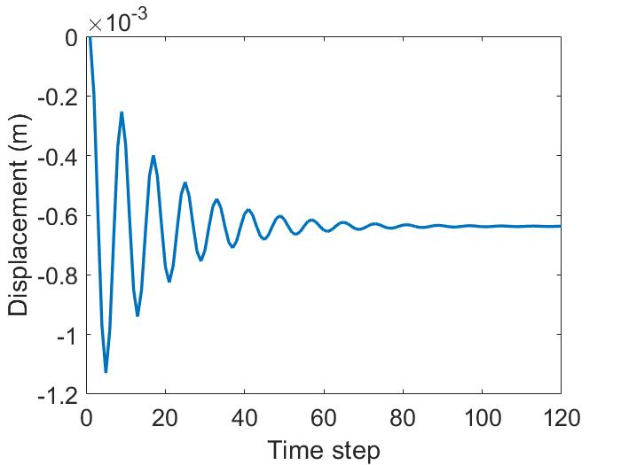

* Case II (Coarse Mesh) (Time Step- 1 X 10 -3)

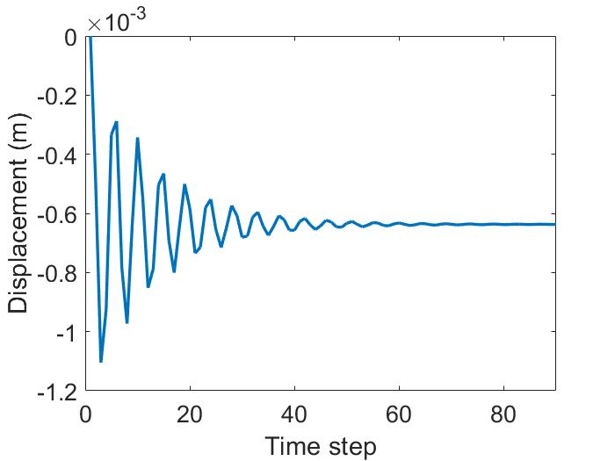

* Case III (Fine Mesh) (Time Step – 0.25 X 10 -3)

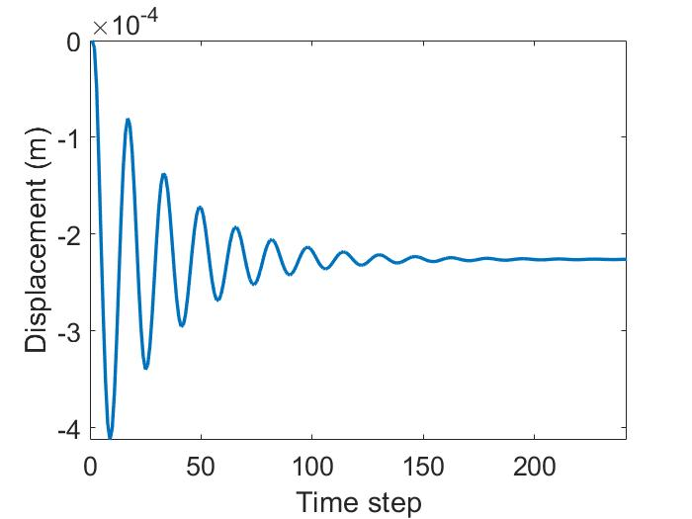

* Case IV (Fine Mesh) (Time Step - 0.5 X 10 -3)

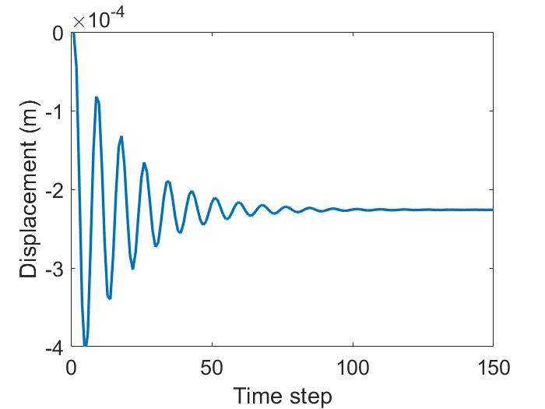

Conclusion & Physical Understanding of the Results

In the above analysis, it is quite significantly observed that the coarse mesh and fine mesh have a significant difference in capturing the displacement over a given time step. Often Coarse mesh results in incorrect results due to the small number of nodes and elements used to compute the overall problem.

Though, the Fine Mesh results are close to the analytical calculations but still not accurate. A point to be noted is that the analytical calculations can only do justice to the static response and cannot effectively calculate and capture the dynamic response accurately.

Furthermore, a mesh convergence study could effectively analyze as to how many numbers of elements increase or decrease affects the problem's overall result. A Mesh Convergence study can also effectively analyze the adequate number of nodes and elements required for the given problem to represent the dynamics involved in the given problem effectively.

A Validation plan also needs to be developed using the Commercial Software package to validate & verify the results obtained for different mesh conditions. A Verification plan can also be devised using the experimental analysis data of physical testing.